WT-X11
Voice Prompter (Body Induction)

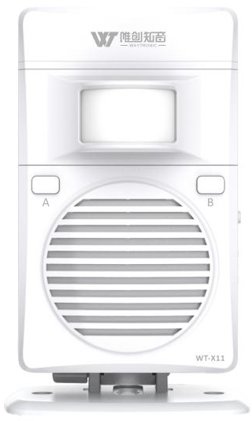

- Product features
- Small and exquisite, playing MP3 audio with excellent sound quality.
- Using human body induction, when a person passes through the sensing area, it will immediately trigger and play voice( induction distance: ≤4m)
- Built in 32Mbit=4M byte memory, the voice content can changed freely by U disk.
- Built-in powerful lithium battery and low power consumption design, allow unit has longer working time.
- With charging management, low battery remind function.
- Equipped with mounting brackets, which are convenient and quick to install.
- Widely used in supermarkets, convenience stores, gas stations, high-speed service areas and stations.
2. Electrical parameters
Power supply mode | DC3V~ 5V stabilized voltage supply
 | 3.7V 1500 mAH lithium battery
Working Current | Sleep standby mode |  | ≤40uA
 | Playing mode |  | ≤330mA(DC4.7V)
Charging Current | ≤950mA
Audio Format | MP3 | Bit Rate: 8~320Kbps
Audio Output Power | 8Ω/2W(typical value)
Infrared Induction Range | ≤3m(120°Angle)
Volume | ≥100dB
Battery lasting time | In fully charged state, playing 50 times a day, 10 seconds long voice, battery can last more than a month
3. Appearance introduction
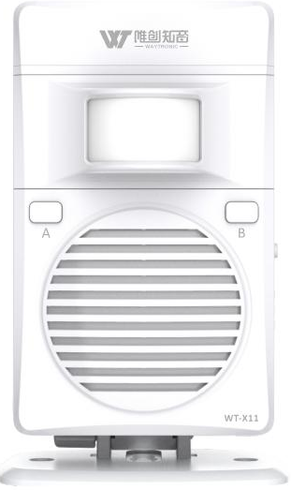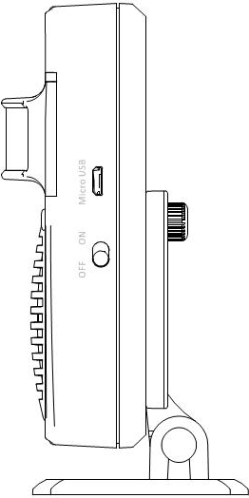
Bracket
On/off button
Micro USB
Speaker
B button
A button
PIR sensor

LED indicator

3.1 Button function
Button name | Operation | Function
On-off button | Switch | Turn on/off
A button | Short press | Next audio（all loop）
 | Long press 3 seconds | Single playing mode（Red light flashes 3 times）
B button | Short press | Volume adjust（1-8 level）
 | Long press 3 seconds | All loop playing mode（Red light flashes 3 times）

3.2 LED function
LED color | function | Working condition
Red | Playing | Red LED on when playing,off when finish playing
 | Low battery warning | Red LED flashes 5 times without sound playing
 | Charging | The red LED flashes slowly when charging, and keeps on when playing
Blue | Full charge | The blue LED keeps on
Red and blue | Turn on | Red and blue lights flashing
 | Copy audio | The Red and blue lights flashing

- Audio download
① Connect the computer via the micro USB data cable, and recognize the removable disk.
② Copy the prepared MP3 voice to the removable disk.
③ Disconnect the data cable, short press the A button to listen the audio.
5. Installation
5.1 Bracket assembly
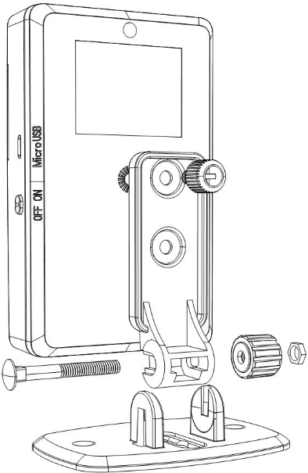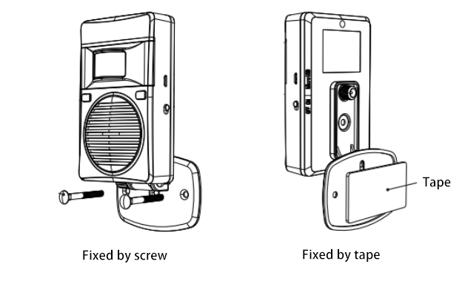
4.2 Installation diagram
① Fixed on the door
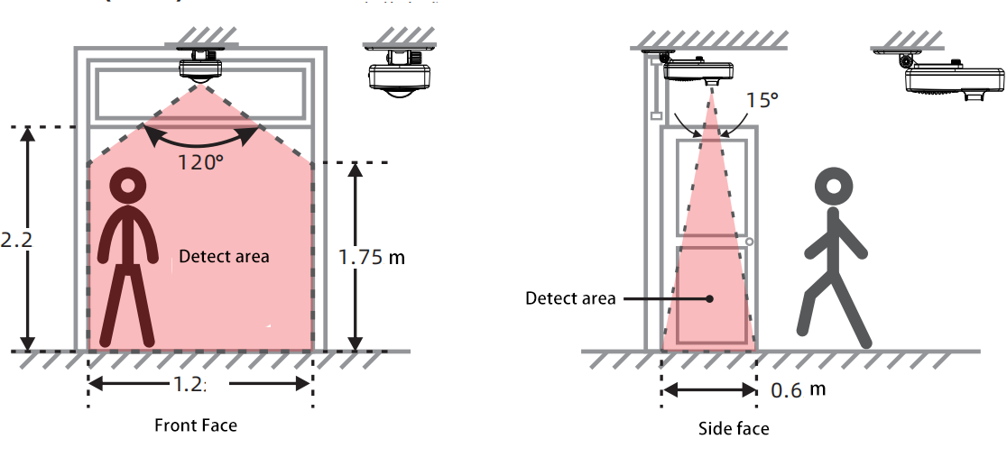
② Side installation
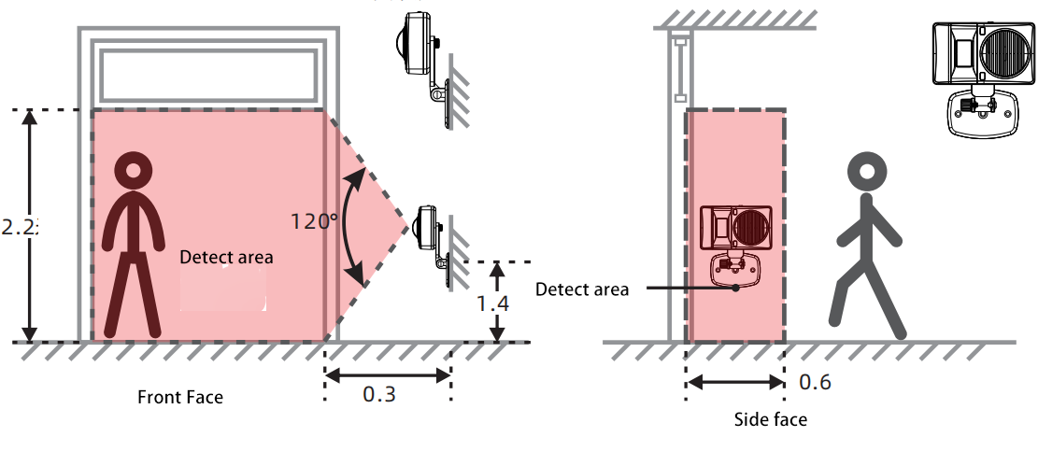

③ Aisle installation
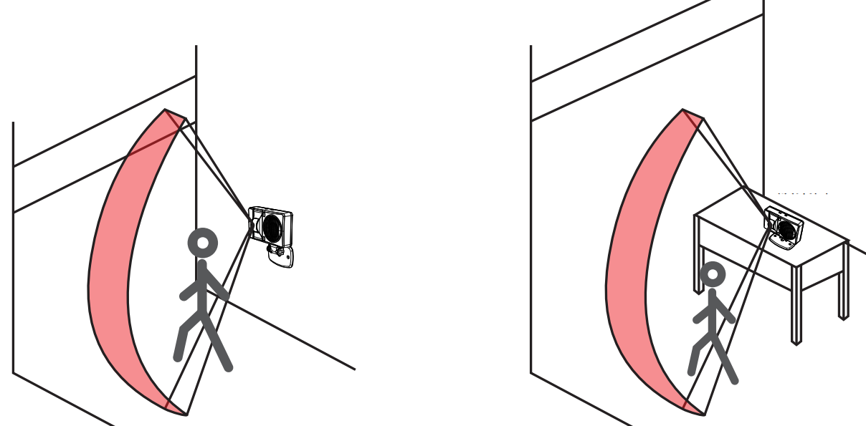

Notice:
1. Too high temperature (≥33℃) will affect the sensing distance and sensitivity.
2. The air conditioner and the fan facing the sensor head will affect the sensing distance and sensitivity.

- FAQ
Problem | Solution
Volume is too low | Press B button to adjust the volume
No sound | - Whether the unit has turn on  - Whether the unit is in low battery(Red LED flashes 5 times without sound playing)
Can not recognize the removable disk | 1.Whether the USB cable has date transfer function  2.Whether the USB cable is connect correctly

- Accessories
Name | Quantity
Host | 1 pcs
Bracket | 1 set
5V 1A USB adapter | 1 pcs
USB cable | 1 pcs
User manual | 1 pcs

Disclaimer
Shenzhen Waytronic Electronics Co., Ltd. reserves the right to modify the use of materials without notifying customers. The new product specifications will be subject to the latest version of the usage data.
Contact Us
Shenzhen Waytronic Electronics Co., Ltd.
Tel: +86-755-29605099
Fax : +86-755-29606626
Website: en.waytronic.com
E-mail: WT1999@waytronic.com
Add:4/F,Building No.11,Fuan Robotics Industrial Park, Fuyong,Baoan District,Shenzhen ,518103,Guangdong ,China

